Practise Questions - Mode
- Find the median and mode of the following data.
(a) 12, 8, 4, 8, 1, 8, 9, 11, 9, 10, 12, 8
(b) 15, 22, 17, 19, 22, 17, 29, 24, 17, 15
- The runs scored in a cricket match by 11 players is as follows:
7, 16, 121, 51, 101, 81, 1, 16, 9, 11, 16
Find the mean, mode, median of this data.
- The marks obtained by 40 students out of 50 in a class are given below in the table.
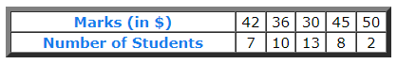
Find the median & mode of the above data.

- Calculate the Arithmetic Mean, median & Mode from the following data

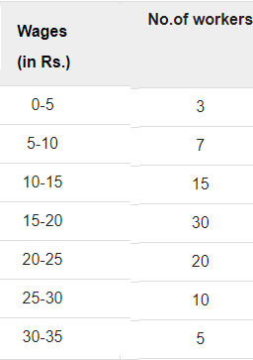

- Find the median & mode from the following data
